**Lab 4: HDFS Storage**

Objective: To view and manage HDFS files and directories using the HDFS Shell, the Ambari Files View and the NameNode UI

[root@golden-node1 ~]# hdfs dfs -help

[root@golden-node1 ~]# hdfs dfs –ls <file:///usr>

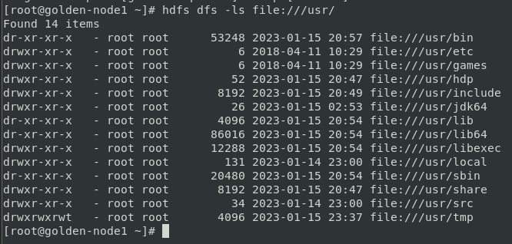

[root@golden-node1 ~]# hdfs dfs -ls hdfs:///user

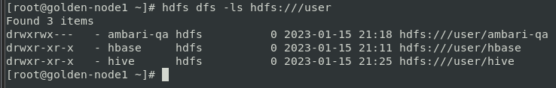

[root@golden-node1 ~]# hdfs dfs –ls /user

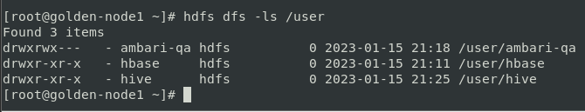

* hdfs dfs -ls hdfs:///user and, hdfs dfs -ls /user (both are showing the same result)

**Using the HDFS Shell**

[root@golden-node1 ~]# hdfs dfs –ls /

* list down the file and dir. In the HDFS root (/) directory

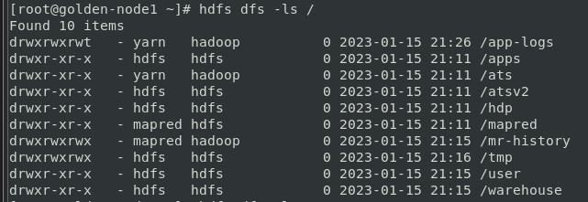

[root@golden-node1 ~]# hdfs dfs –ls

* This Command does not run or fails because root user does not have HDFS home dir.

[root@golden-node1 ~]# hdfs dfs –mkdir /user/root

* Fails because root user does not have HDFS permission to write to the /user directory



[root@golden-node1 ~]# more /etc/hadoop/conf/hdfs-site.xml

* This file will tell about which user has SuperUser priviledge in HDFS

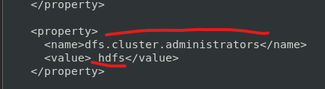

[root@golden-node1 ~]# su - hdfs

Last login: Sun Jan 15 22:01:11 IST 2023

[hdfs@golden-node1 ~]$ ls

[hdfs@golden-node1 ~]$ hdfs dfs -mkdir /user/root

[hdfs@golden-node1 ~]$ hdfs dfs -ls /user

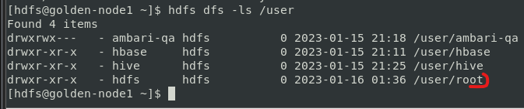

[hdfs@golden-node1 ~]$ hdfs dfs -chown root:root /user/root

[hdfs@golden-node1 ~]$ hdfs dfs -ls /user

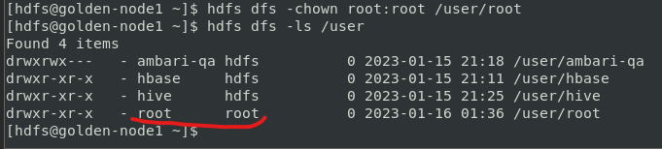

[hdfs@golden-node1 ~]$ exit

[root@golden-node1 ~]$ hdfs dfs –ls

* Command execute but does not show any file and directory

[root@golden-node1 ~]# hdfs dfs -mkdir -p dir1/dir2/dir3

* Creating 3 directory at a time as a normal root user

[root@golden-node1 ~]# hdfs dfs –ls



[root@golden-node1 ~]# hdfs dfs -ls -R

* Showing recursively directory structure

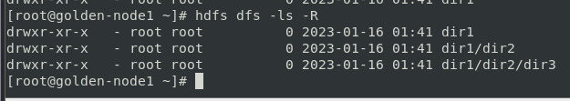

[root@golden-node1]# wget <https://raw.githubusercontent.com/HortonworksUniversity/Ops_Labs/master/const.txt>

[root@golden-node1 ~]# hdfs dfs -put const.txt constitution.txt

* **Copying** the “constitution.txt” file system from the local file system as a root user

[root@golden-node1 ~]# hdfs dfs –ls

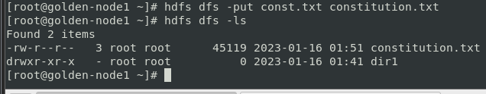

[root@golden-node1 ~]# hdfs dfs -cat constitution.txt

* Seeing the content of the file

[root@golden-node1 ~]# hdfs dfs -tail constitution.txt

* Only able to see last 1 KB of the file

[root@golden-node1 ~]# hdfs dfs -get constitution.txt /root/constitution.txt

* Copying constitution.txt file from root user of HDFS home directory to root user home directory in the local file system



[root@golden-node1 ~]# ls

[root@golden-node1 ~]# hdfs dfs -mv constitution.txt dir1/dir2/dir3

* Moving constitution.txt file from root user HDFS home directory to HDFS directory /user/dir1/dir2/dir3

[root@golden-node1 ~]# hdfs dfs -ls

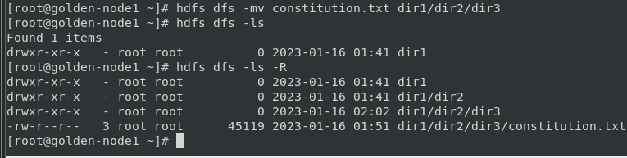

[root@golden-node1 ~]# hdfs dfs -ls -R

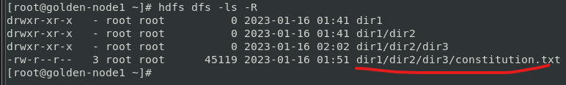

[root@golden-node1 ~]# hdfs dfs -put /etc/passwd passwd

[root@golden-node1 ~]# hdfs dfs -put /etc/hosts hosts

* Copying /etc/passwd and /etc/hosts fil from local system to root user HDFS home directory

[root@golden-node1 ~]# hdfs dfs –ls

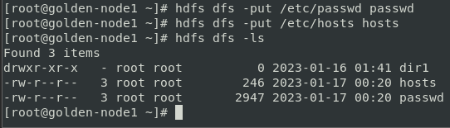

[root@golden-node1 ~]# hdfs dfs -getmerge passwd hosts /root/passwd_hosts

* Again Copying and merging passwd and hosts file from root user HDFS home directiory to local file system with a single file name

[root@golden-node1 ~]# hdfs dfs -rm passwd

[root@golden-node1 ~]# hdfs dfs –ls



[root@golden-node1 ~]# hdfs dfs -ls -R .Trash

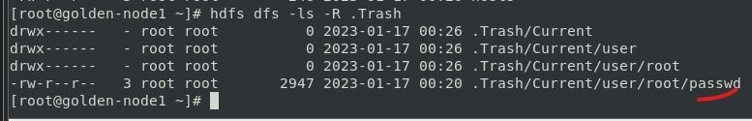

[root@golden-node1 ~]# hdfs dfs -mv .Trash/Current/user/root/passwd passwd

[root@golden-node1 ~]# hdfs dfs -ls –R

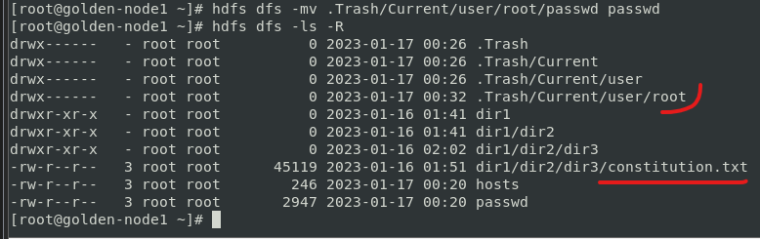

[root@golden-node1 ~]# hdfs dfs -ls dir1/dir2/dir3

[root@golden-node1 ~]# hdfs dfs -rm dir1/dir2/dir3

* rm: `dir1/dir2/dir3': Is a directory

[root@golden-node1 ~]# hdfs dfs -rm -R dir1/dir2/dir3

[root@golden-node1 ~]# hdfs dfs -ls dir1/dir2/dir3

* ls: `dir1/dir2/dir3': No such file or directory

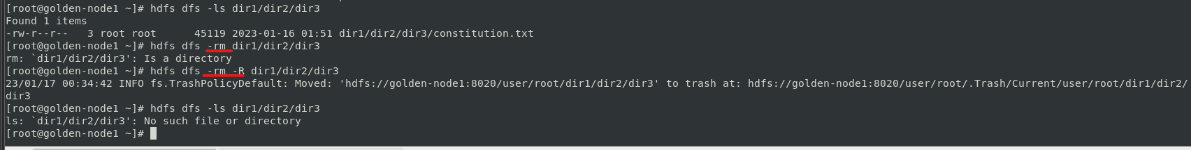

**Override Default HDFS Properties**

[root@golden-node1 ~]# more /etc/hadoop/conf/hdfs-site.xml

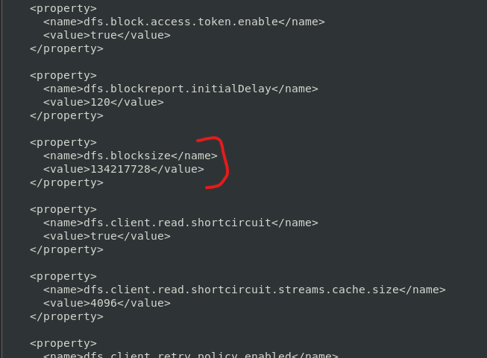

[root@golden-node1 ~]# hdfs dfs -D dfs.blocksize=1000000 -put /etc/passwd test_data

[root@golden-node1 ~]# hdfs dfs -D dfs.blocksize=1050000 -put /etc/passwd test_data

[root@golden-node1 ~]# hdfs dfs -D dfs.blocksize=1049088 -put /etc/passwd test_data

* Creating blocksize with minimum requirements and above both command through an error

**Configure Ambari Files View**

Go to Browser: golden-node1:8080

Username: admin

Password: admin

Services 🡪 Select HDFS service

Select Config 🡪 Click on Advanced and choose config group as default

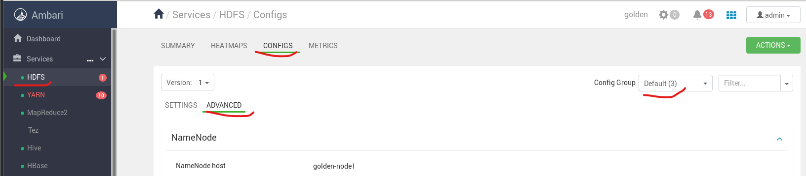

Search custom core-site 🡪

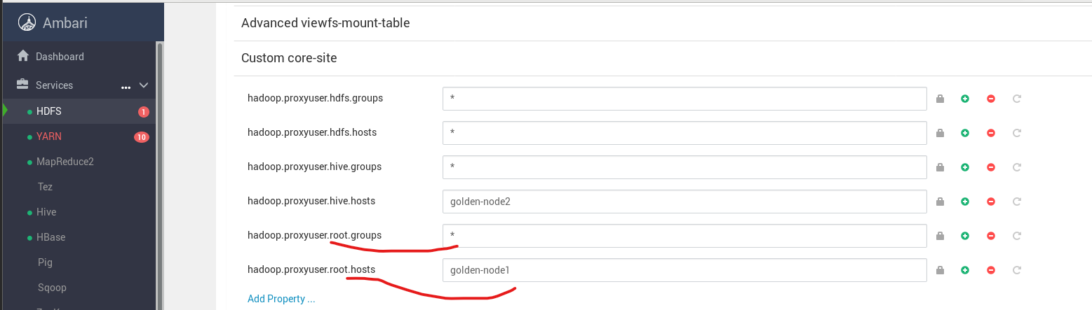

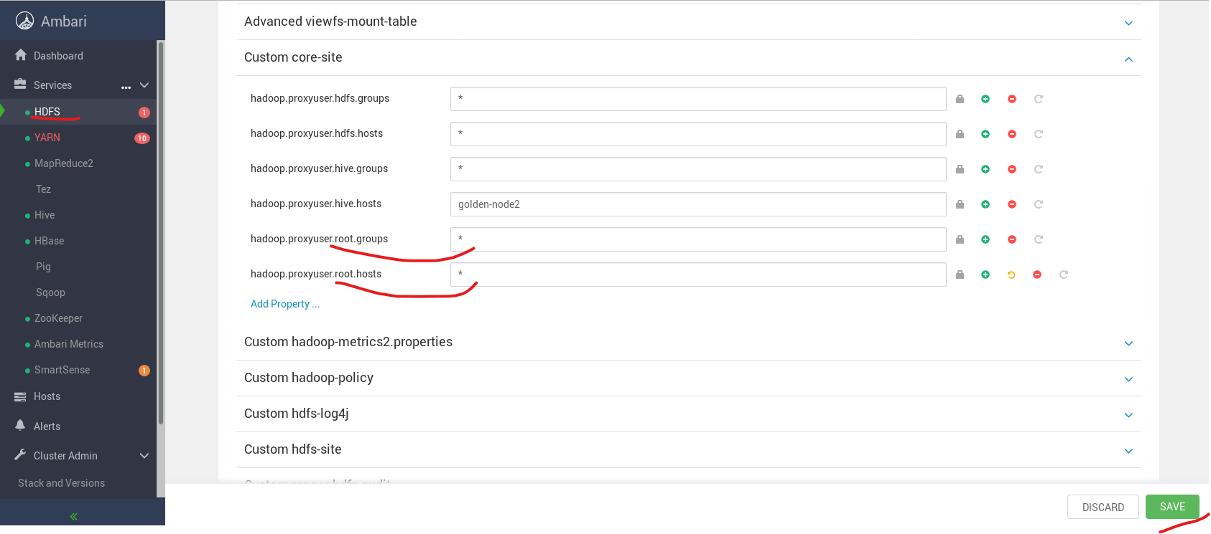

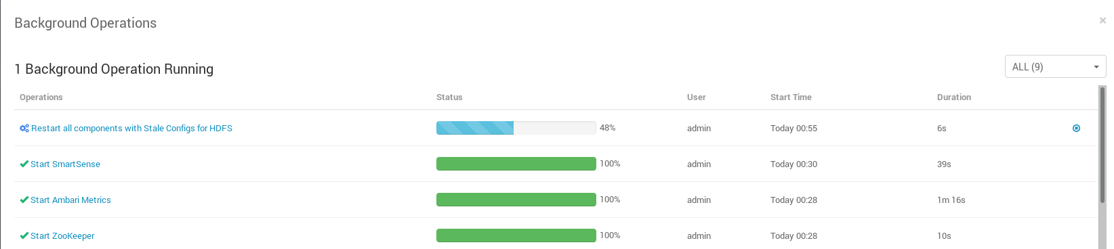

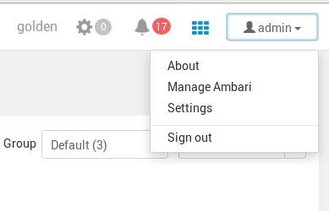

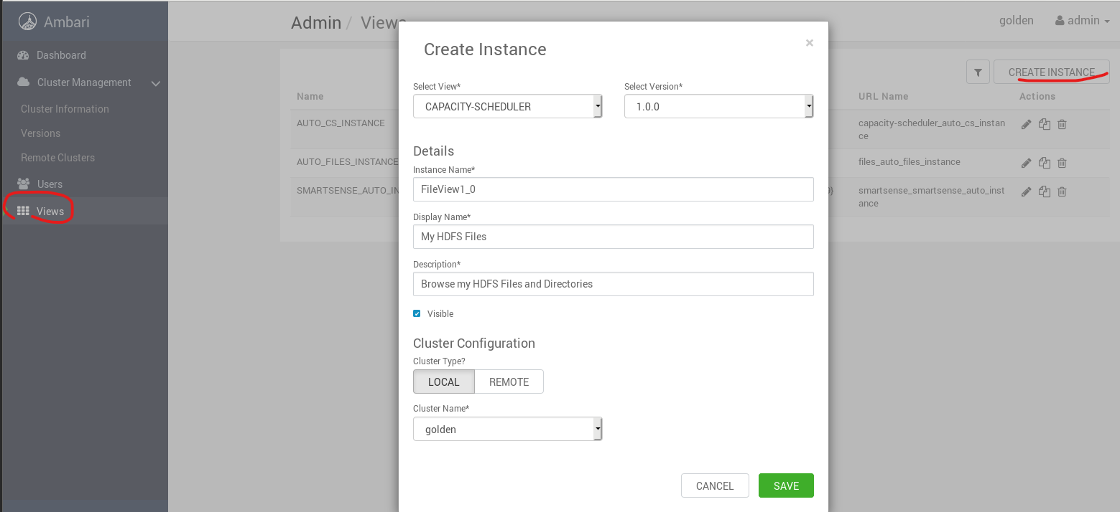

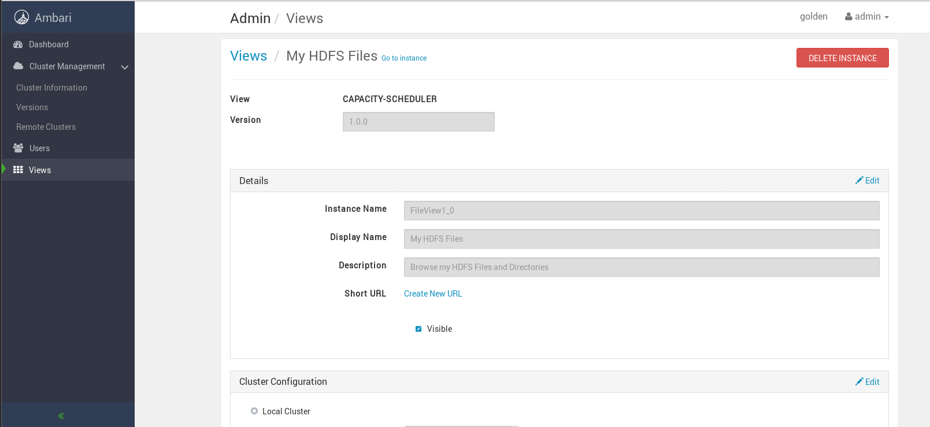

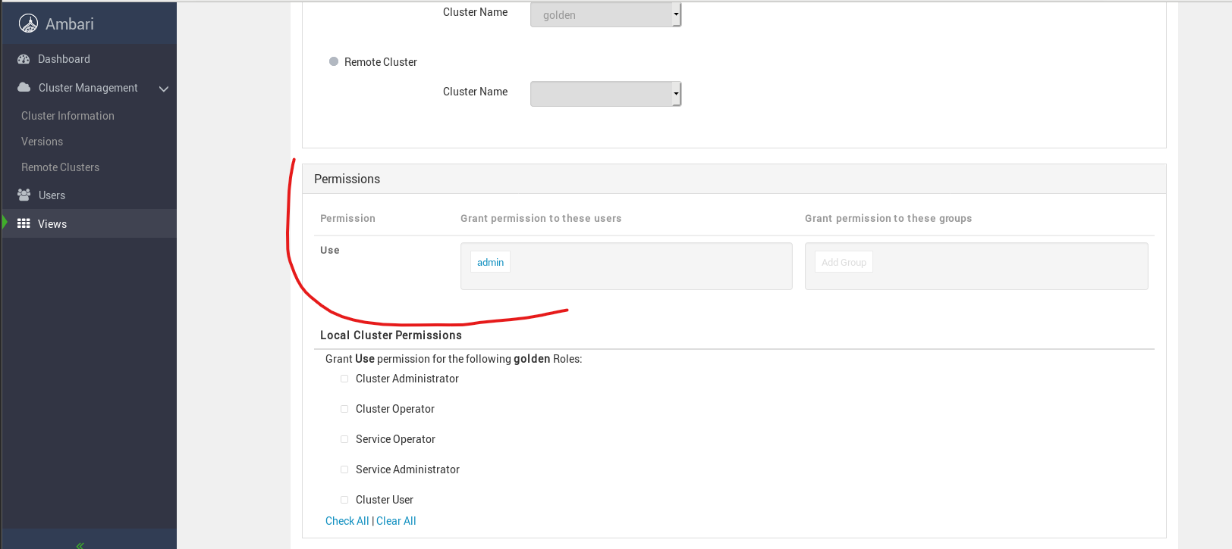

[root@golden-node1 ~]# su - hdfs

[hdfs@golden-node1 ~]$ hdfs dfs -mkdir /user/admin

[hdfs@golden-node1 ~]$ hdfs dfs -chown admin:admin /user/admin

[hdfs@golden-node1 ~]$ exit

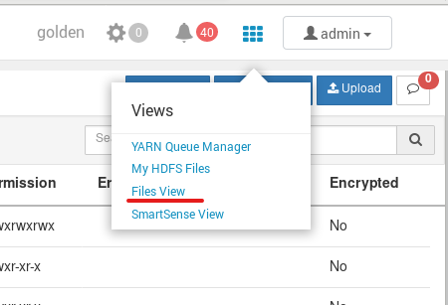

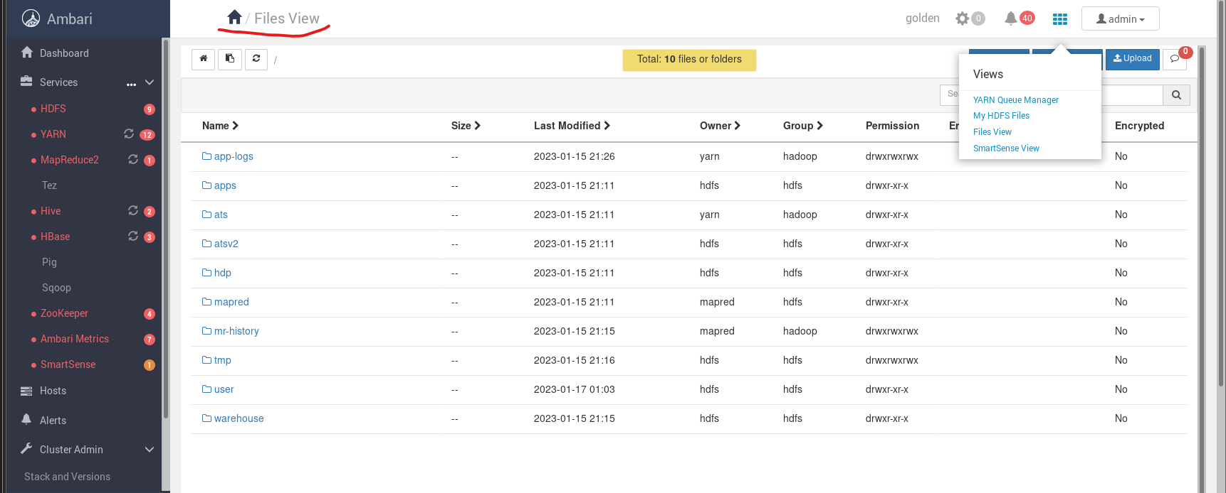

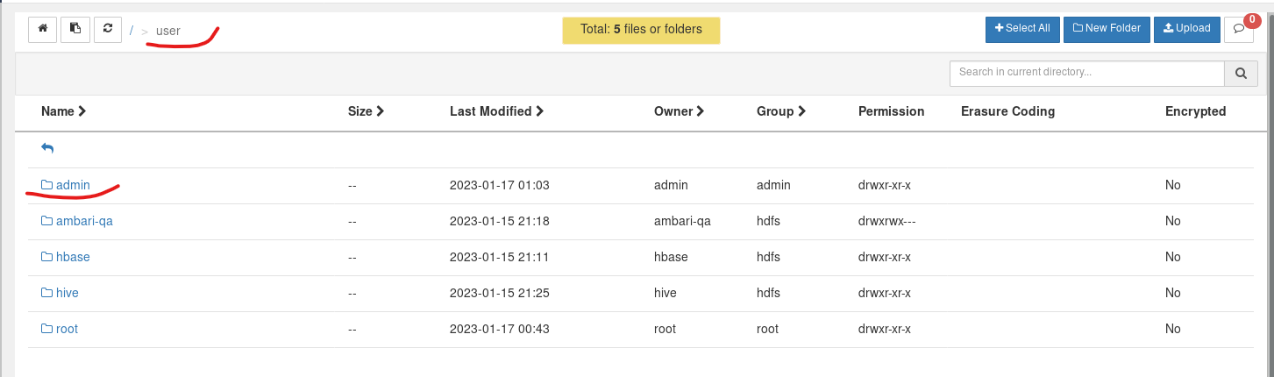

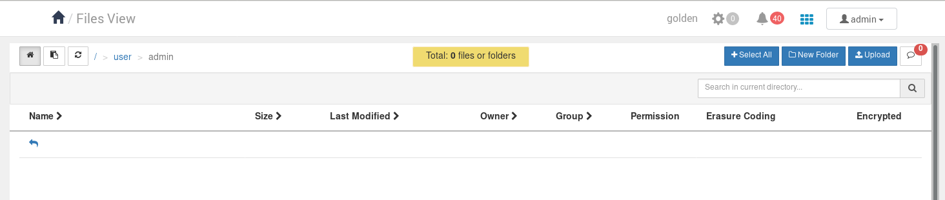

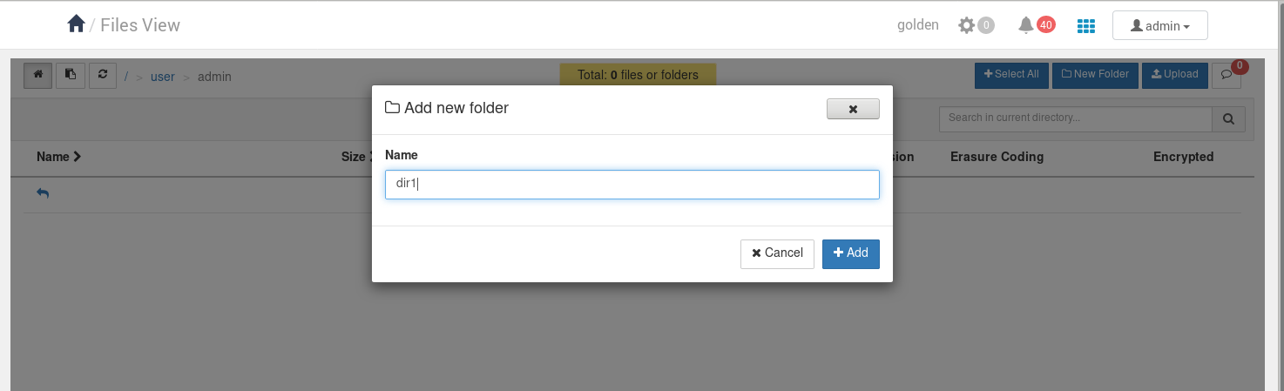

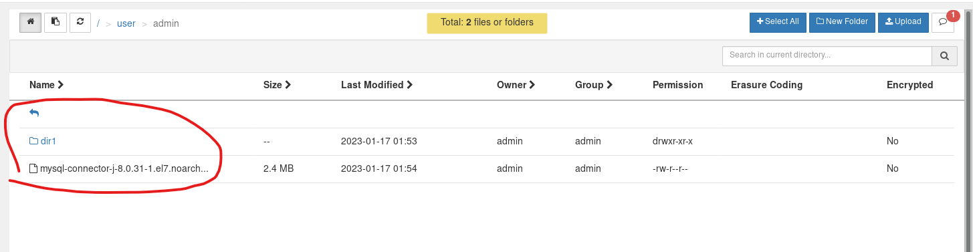

**Using the NameNode UI File Browser**

